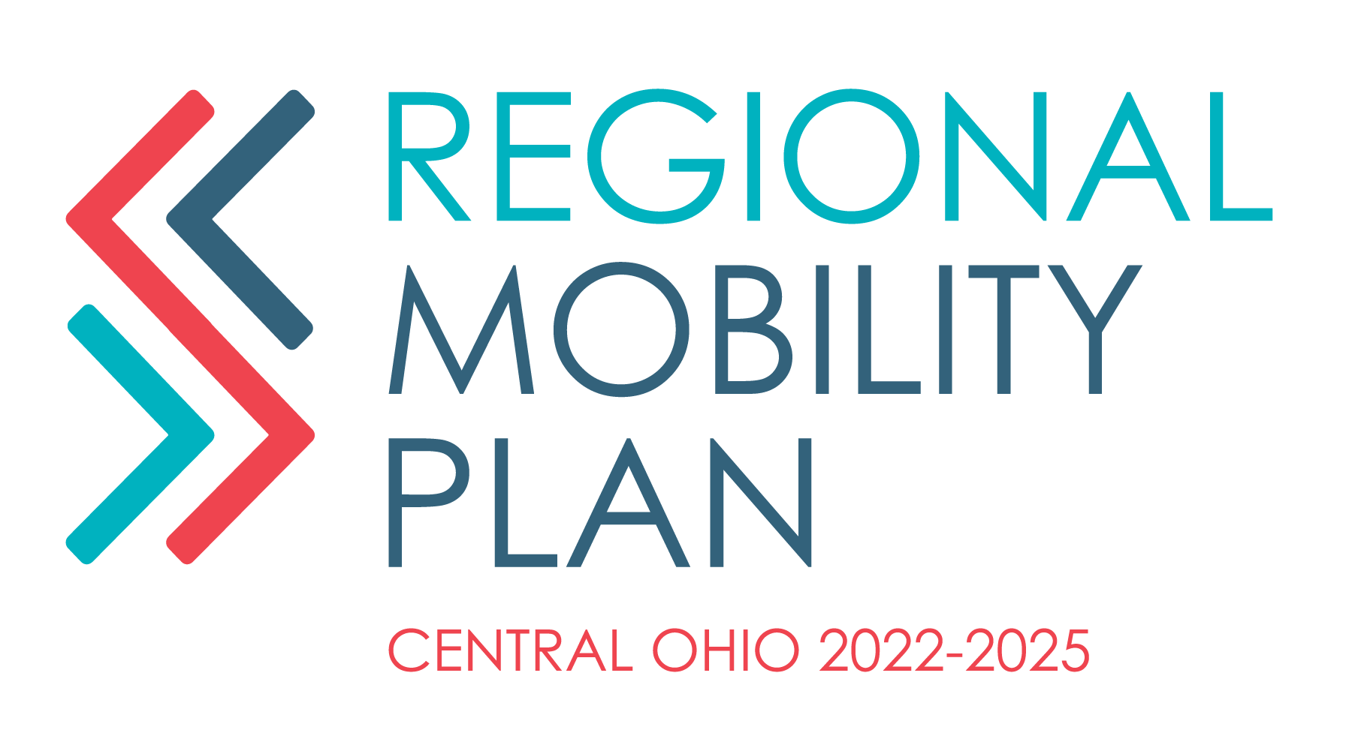

**NOTICE OF A MEETING**

**FRANKLIN COUNTY MOBILITY ADVISORY COMMITTEE MEETING**

MID-OHIO REGIONAL PLANNING COMMISSION

111 LIBERTY STREET, SUITE 100

COLUMBUS, OH 43215

*BOARD ROOM CONFERENCE ROOM*

**January 8th, 2024**

**10:00 AM**

**AGENDA**

1. **Welcome**
2. **Updates**
   1. Roundtable updates – upcoming events or initiatives
3. **Discussion Topic**
   1. LinkUS Presentation by Maria Schaper, MORPC
   2. Ohio Loves Transit Discussion
4. **Time for questions/Wrap up**

**PLEASE NOTIFY EMMA STRANGE AT 614-233-4181 OR estrange@morpc.org TO CONFIRM YOUR ATTENDANCE FOR THIS MEETING OR IF YOU REQUIRE SPECIAL ASSISTANCE.**

**The next Mobility Advisory Committee Meeting is**

February 12th, 2023

*111 Liberty Street, Suite 100*

*Columbus, Ohio 43215*

**PARKING AND TRANSIT:** When parking in MORPC's parking lot, please be sure to park in a MORPC visitor space or in a space marked with a yellow “M”. Handicapped parking is available at the side of MORPC’s building. Electric vehicle charging stations are available for MORPC guests.

Indoor bike parking is available for MORPC guests.

MORPC is accessible by COTA BUS. The closest bus stop to MORPC is S. Front Street & W. Blenkner St. Buses that accommodate this stop are the Number 5 - West 5th Ave. /Refugee and the Number 8 - Karl/S. High/Parsons.

