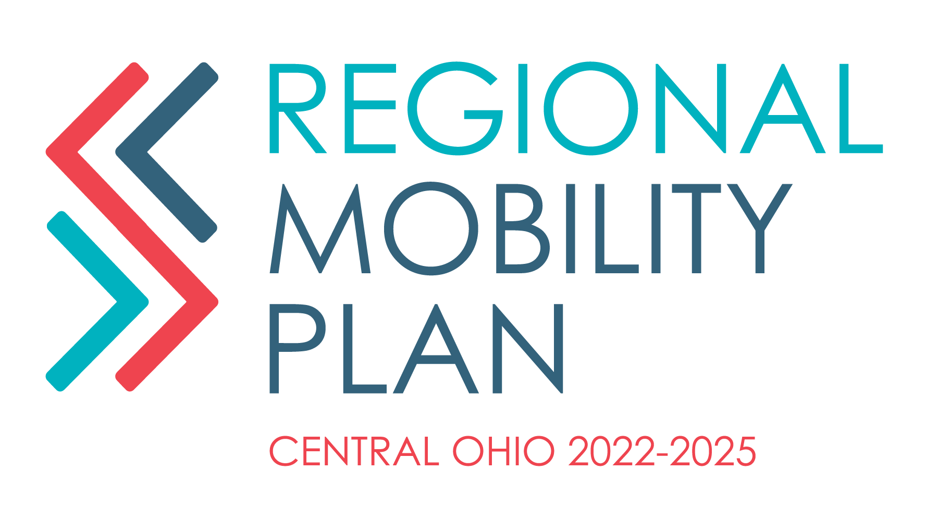

**NOTICE OF A MEETING**

**FRANKLIN COUNTY MOBILITY ADVISORY COMMITTEE MEETING**

MID-OHIO REGIONAL PLANNING COMMISSION

111 LIBERTY STREET, SUITE 100

COLUMBUS, OH 43215

*BOARD ROOM CONFERENCE ROOM*

**May 13th, 2024**

**10:00 AM**

**AGENDA**

1. **Welcome**
2. **Updates**
3. **Discussion Topic:**
   1. COTA Plus Training: June Meeting
   2. Transportation provider survey
4. **Next Meeting**

**PLEASE NOTIFY EMMA STRANGE AT 614-233-4181 OR estrange@morpc.org TO CONFIRM YOUR ATTENDANCE FOR THIS MEETING OR IF YOU REQUIRE SPECIAL ASSISTANCE.**

**The next Mobility Advisory Committee Meeting is**

**June 10th 2024**

*111 Liberty Street, Suite 100*

*Columbus, Ohio 43215*

**PARKING AND TRANSIT:** When parking in MORPC's parking lot, please be sure to park in a MORPC visitor space or in a space marked with a yellow “M”. Accessible parking is available at the side of MORPC’s building. Electric vehicle charging stations are available for MORPC guests.

Indoor bike parking is available for MORPC guests.

MORPC is accessible by COTA BUS. The closest bus stop to MORPC is S. Front Street & W. Blenkner St. Buses that accommodate this stop are the Number 5 - West 5th Ave. /Refugee and the Number 8 - Karl/S. High/Parsons.

