XLS Template

Edit the Template Header
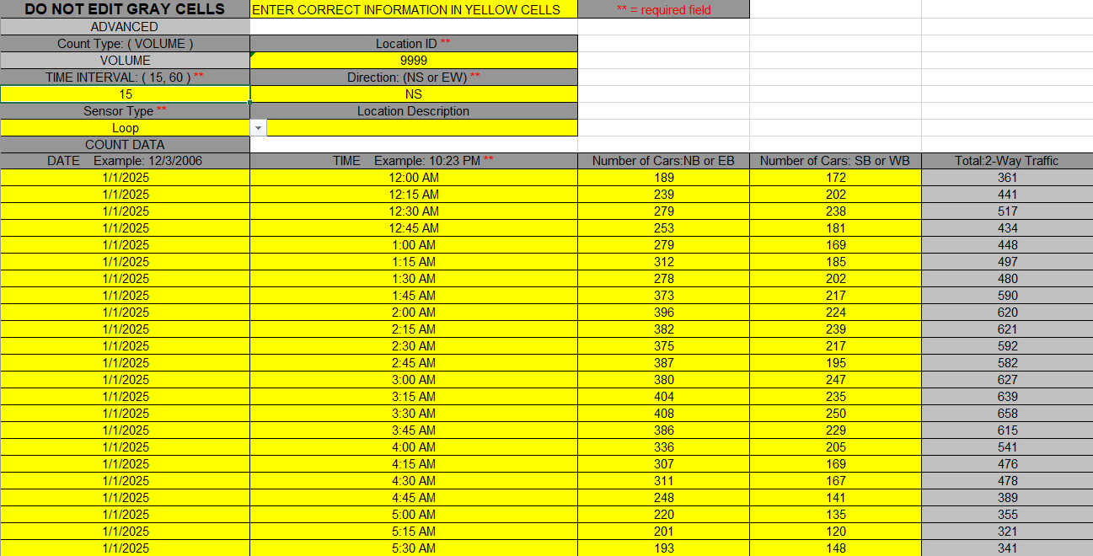
Template for two-way counts occurring every 15 minutes
In the header, update the following:
- Location ID (found online at TCDS (https://morpc.ms2soft.com/tcds/tsearch.asp?loc=Morpc&mod=) by finding the intersection on the map)
- Direction (either NS for north-south or EW for east-west)
- Location Description (same as the file name)

Edit the Count Information in the cells
Enter the count data into the form by direction in the yellow cells.

