*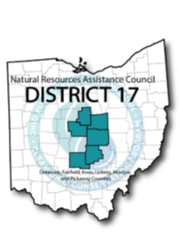 District 17 – Delaware, Fairfield, Knox, Licking, Morrow & Pickaway Counties*

*614-228-2663*

**Clean Ohio Conservation Fund – Fiscal Year 2026**

**Schedule**

**2025**

**January 17**  **Working Session (Methodology, Policies & Criteria)**

|  |  |
| --- | --- |
| Friday, 10am – 12:00pm  **September 19**  Friday, 5:00pm | **Final Applications Due** |
| **September 26**  Friday, 5:00pm  **October 2**  Thursday, 5:00pm | **Applicants Notified of Missing Required Information**  **Submittal of Missing Information** |
| **October 7**  Tuesday, 5:00pm | **PDFs of Applications sent to NRAC members** |
| **October 10**  Friday, 9am – 5:00pm | **Site Visits & Applicant Presentations (Confirm by Oct. 8th)** |
| **October 17 (if necessary)**  Friday, 9am – 5:00pm | **Site Visits** |
| **October 28**  Friday, 5:00p.m. | **Application Scores Due** |
| **November 13**  Thursday, 10:00am – 11:30a.m. | **Scoring & Voting**  (*Project Updates) |

**Submit inquiries to:**

Edwina Teye | 614-233-4233 | [eteye@morpc.org](mailto:eteye@morpc.org)

Mid-Ohio Regional Planning Commission | 111 Liberty Street, Suite 100 | Columbus, OH 43215

The meetings will be held in-person. Please check MORPC’s [meetings and events webpage](https://www.morpc.org/meetings-events/) for details.